Task 5 – Data Mart Load
Data Load – dim_date
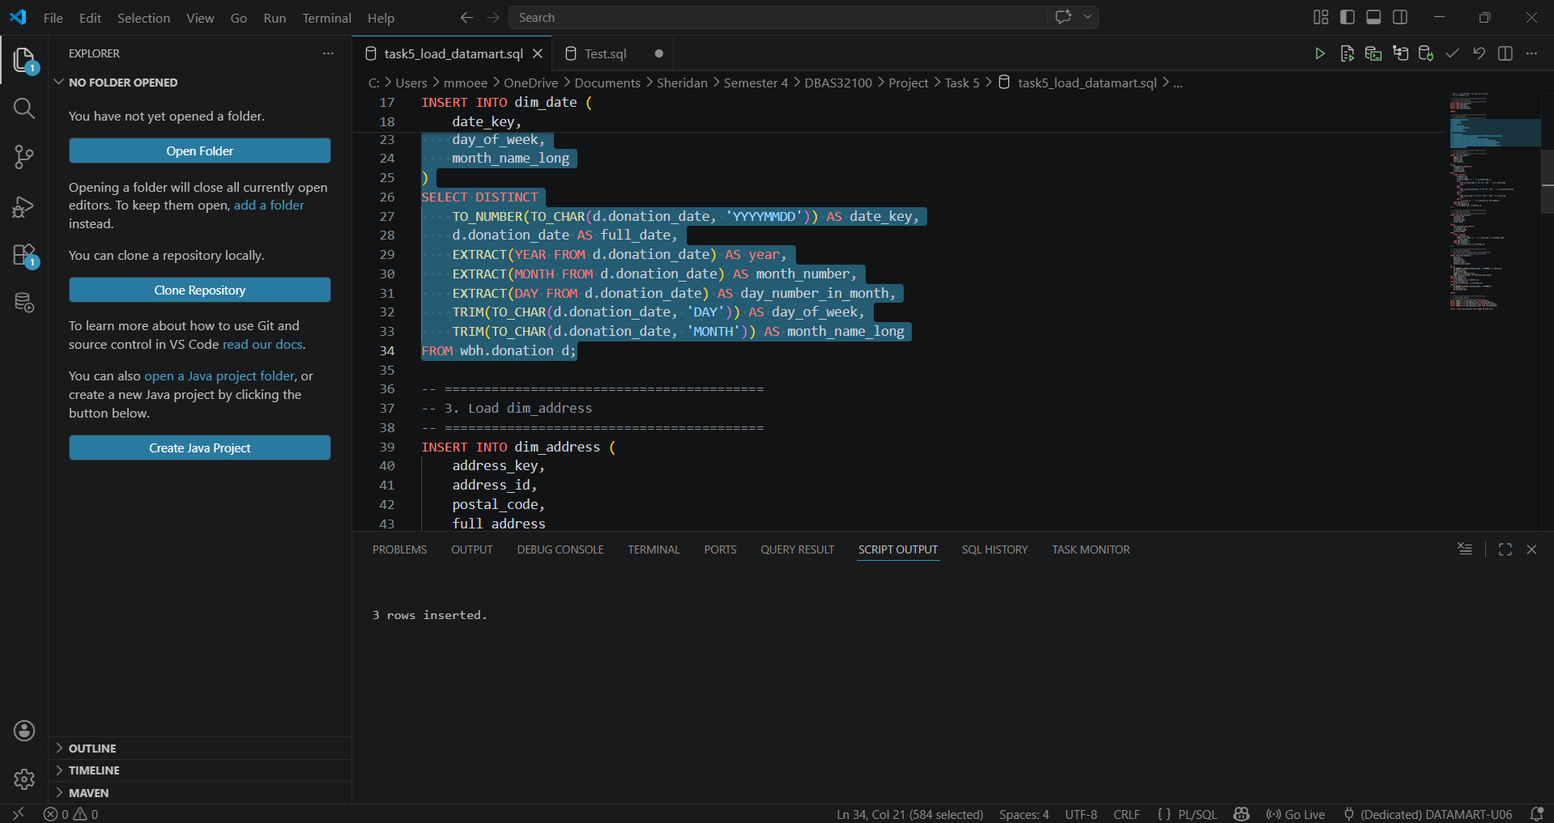
Confirms that 3 rows were inserted into the date dimension.

Data Load – dim_address
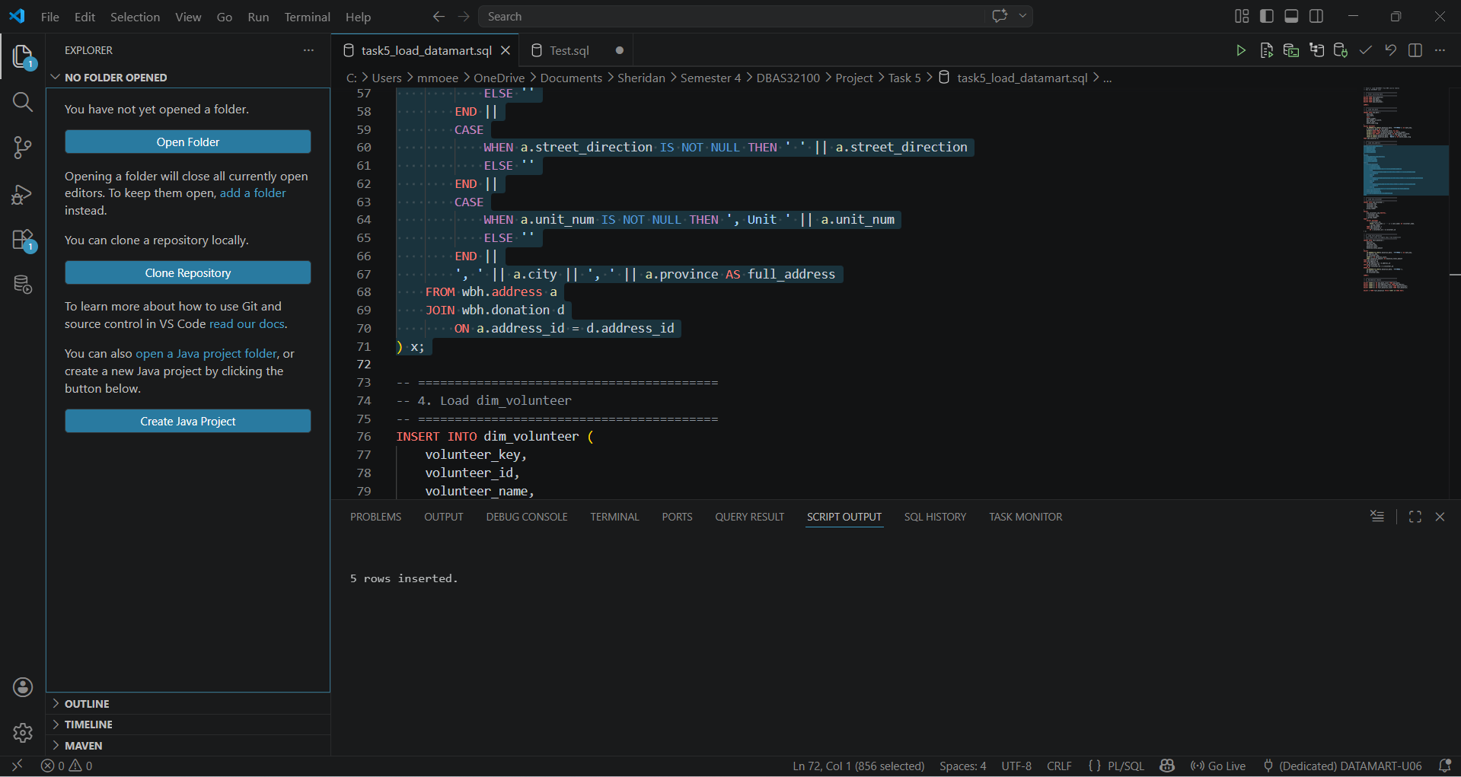
Confirms that 5 rows were inserted into the address dimension.
Data Load – dim_volunteer
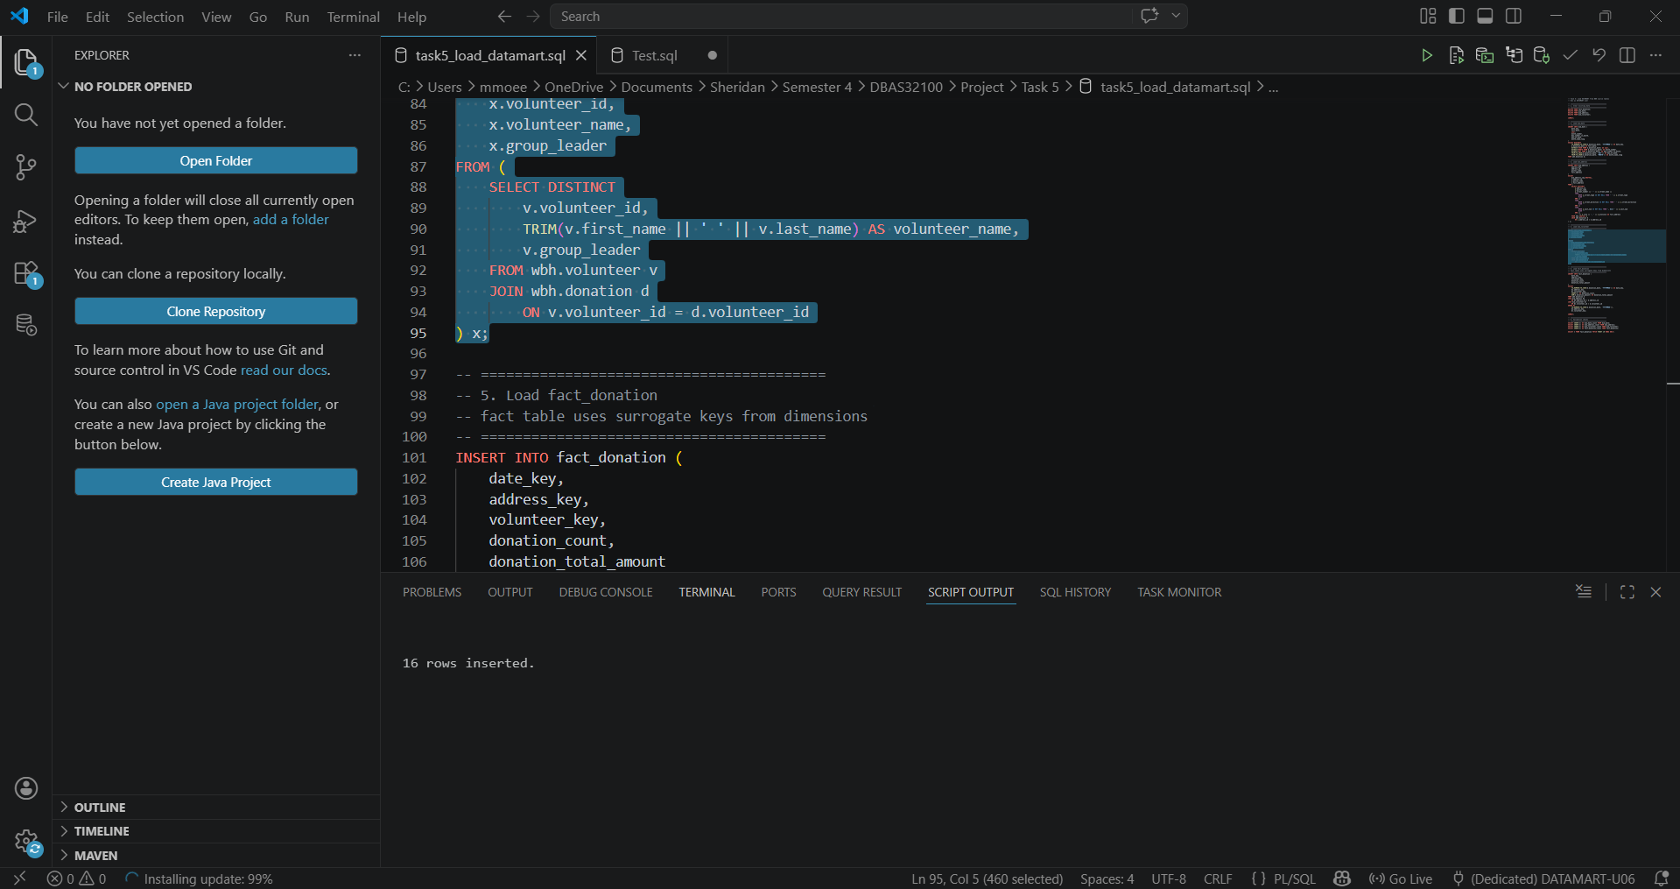
Confirms that 16 rows were inserted into the volunteer dimension.

Data Load – fact_donation
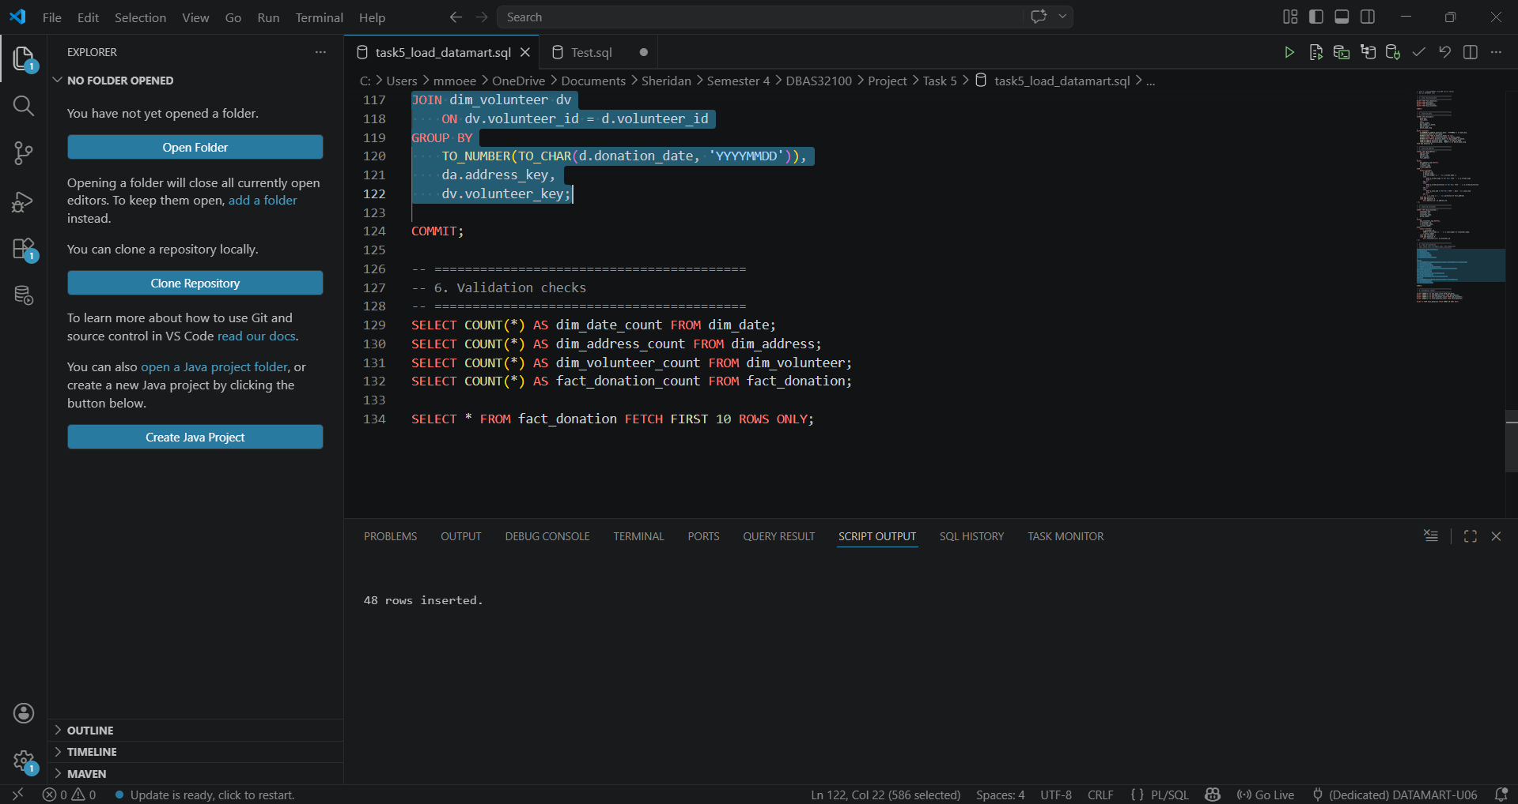
Confirms that 48 rows were inserted into the fact table after aggregation.

Commit
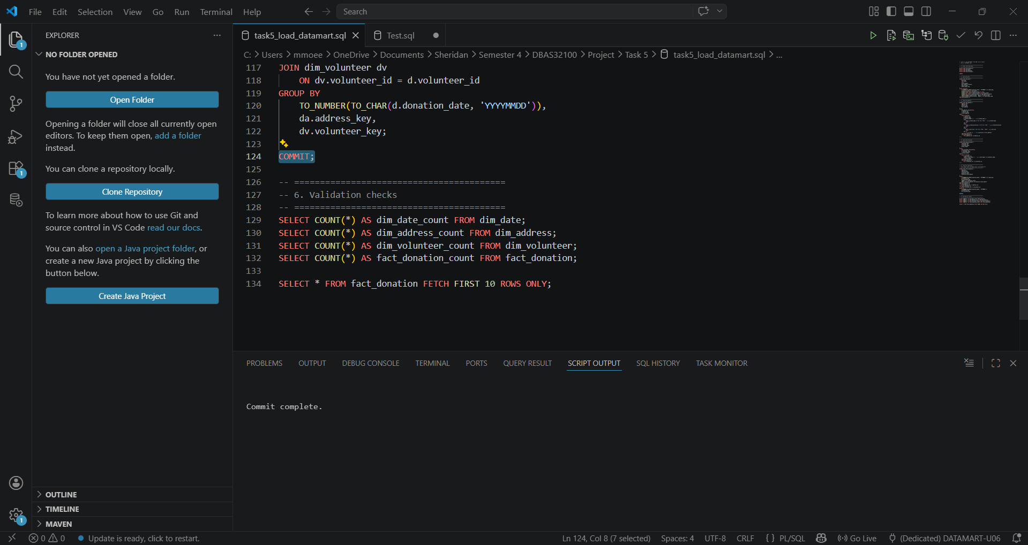
Confirms that all changes were saved to the database.

Count Queries:
Verifies that the correct number of records exist in each table after loading.
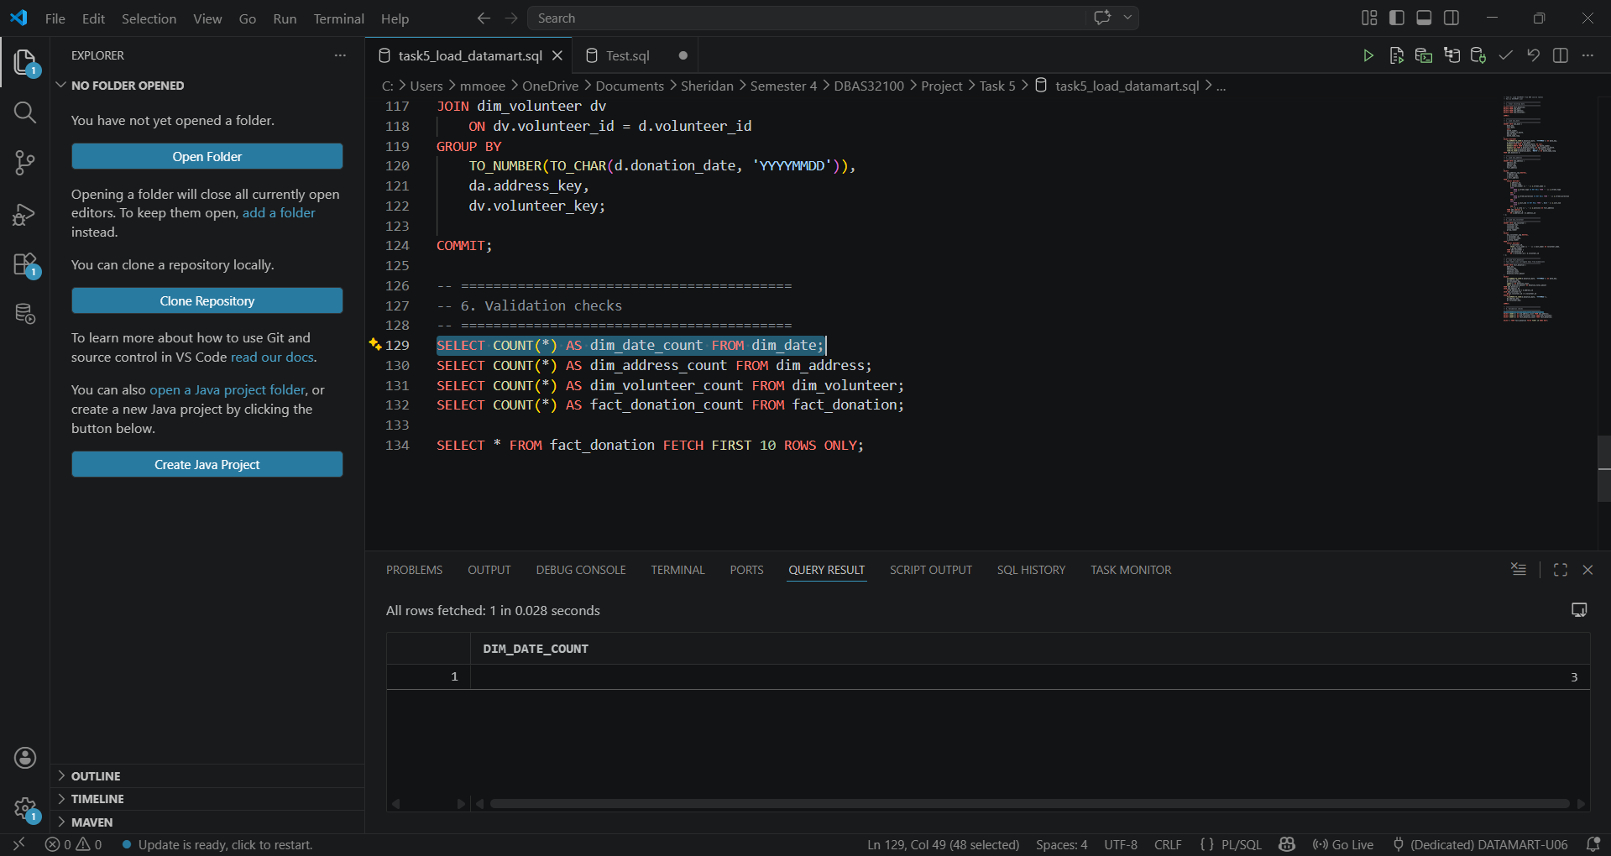

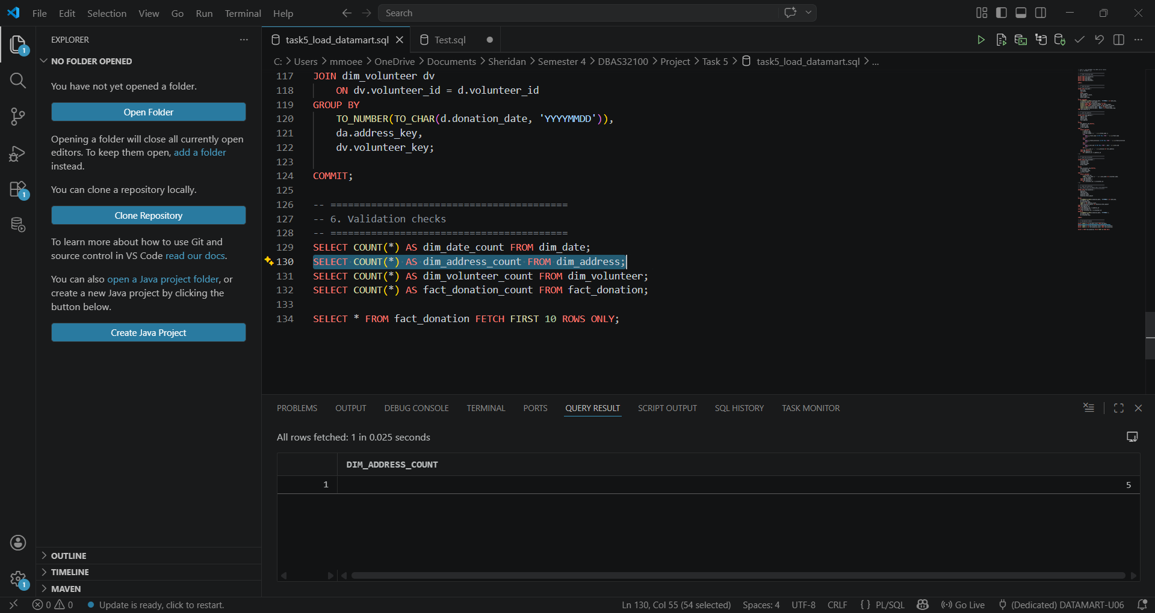

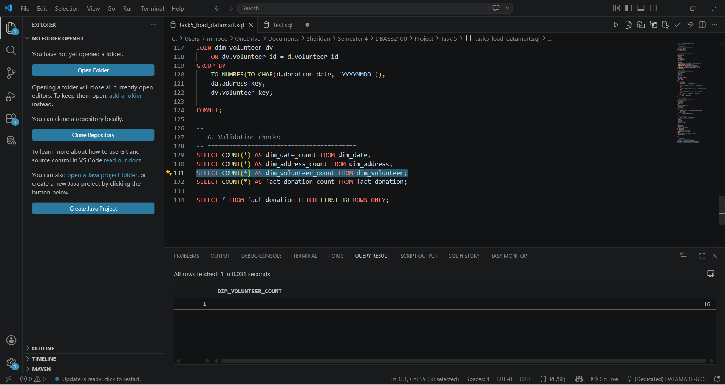

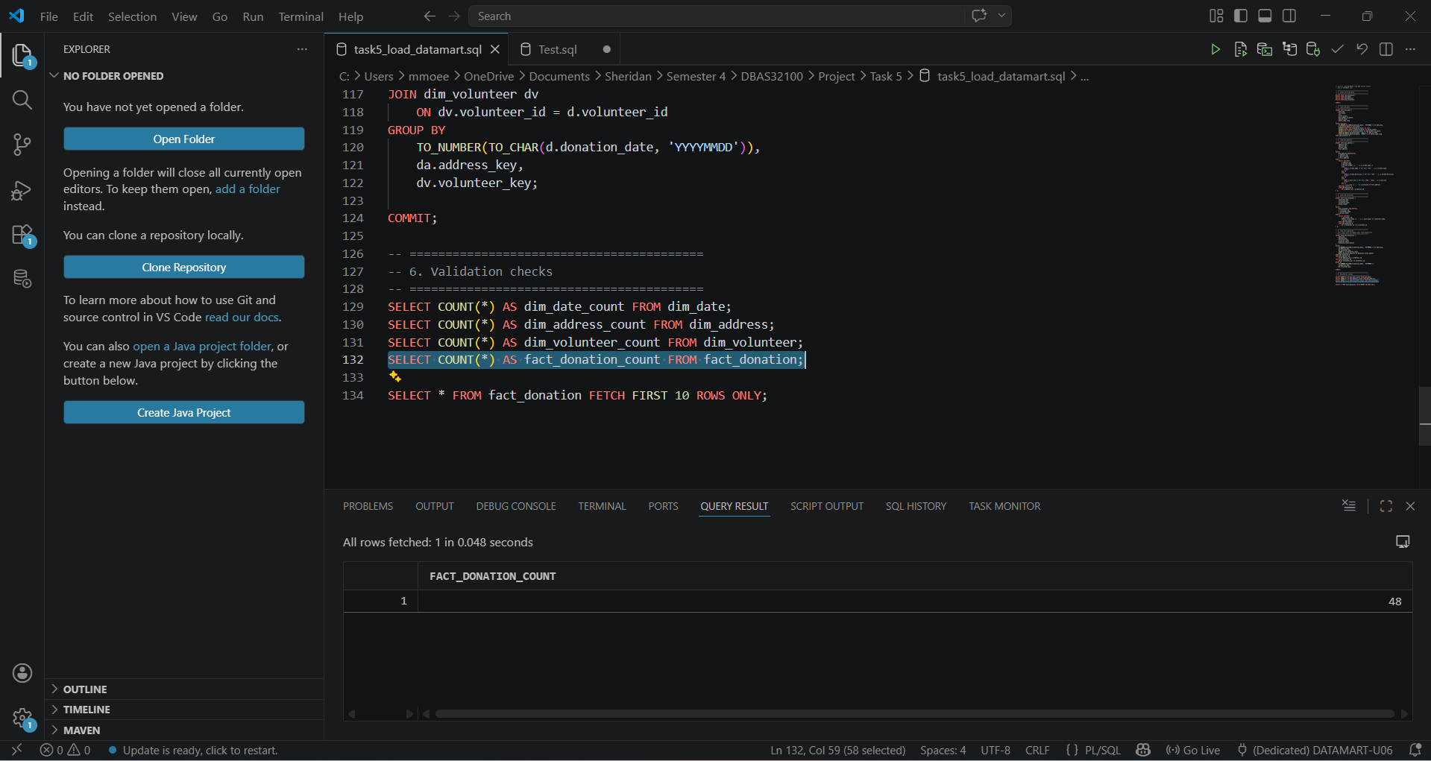

Fact Table Preview
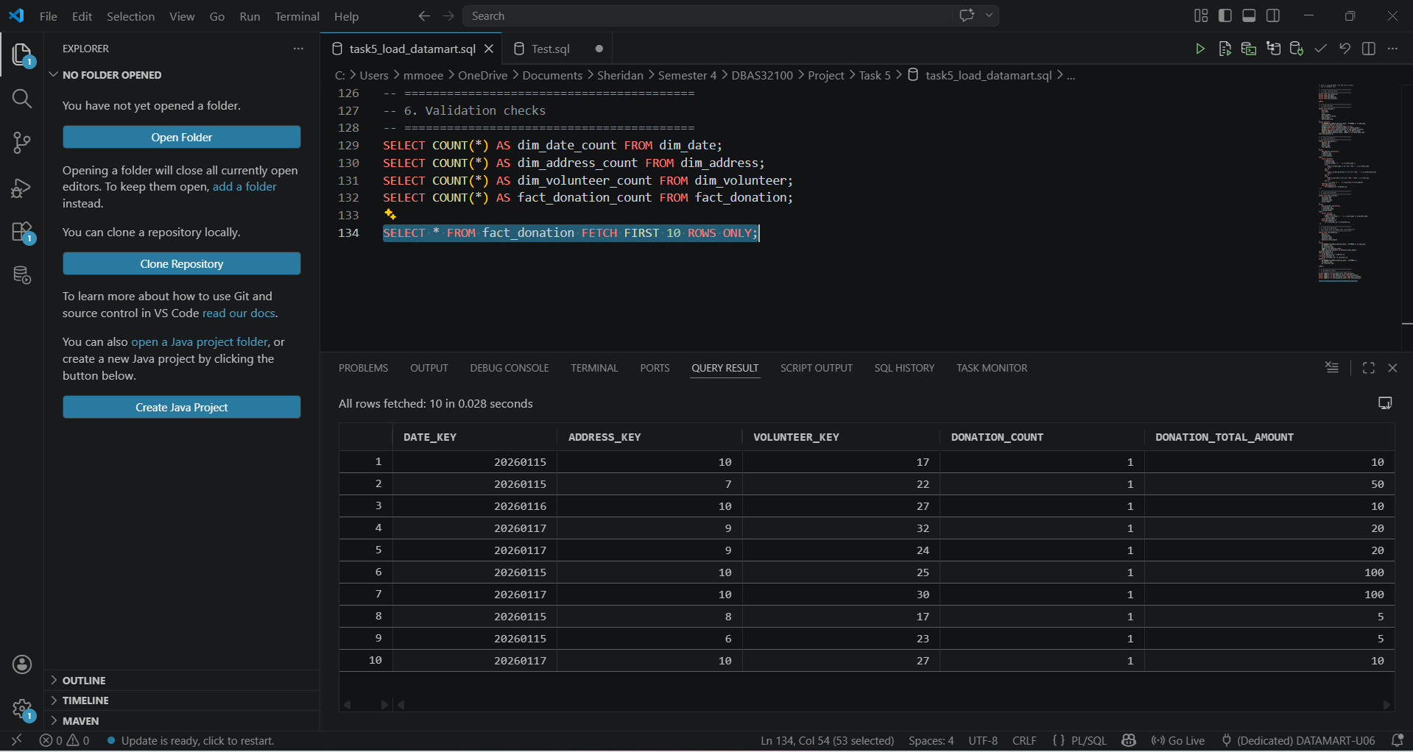
Displays sample records from the fact_donation table, confirming that data was successfully loaded and structured correctly.

